Instructions for setting up Git on Eclipse:

1. Set-up Git for windows as you would normally (and clone the project to your local drive). Pay attention to where your local repository is stored. You’ll need this address below.
2. Download EGit plug-in for eclipse <http://www.youtube.com/watch?v=I7fbCE5nWPU>
3. Create a new eclipse workspace where you’d like to work on your MIECHV code (this could be a server location: preferably the secure S: drive).
4. Open your MIECHV workspace, select Import from the File menu, select Git/Projects from Git,

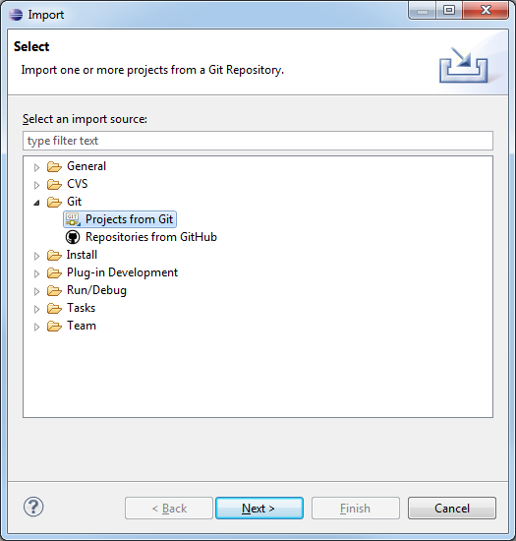

select Local source,

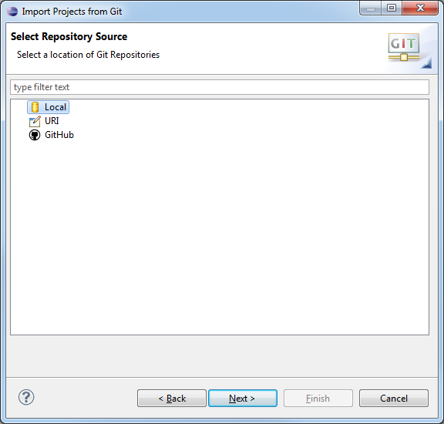

Click the ‘Add’ icon and type in the local repository parent folder location and then hit Search,

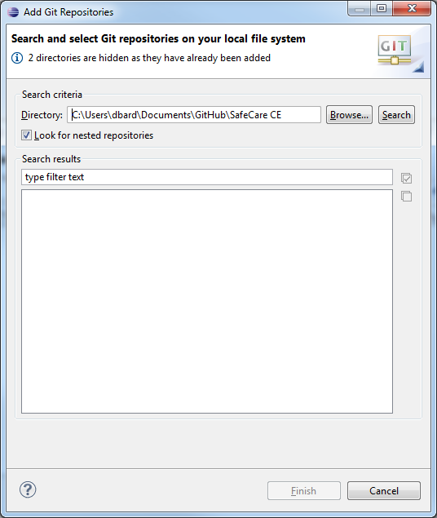

Choose the MReporting repository, and import the project as an existing project.

1. Would suggest continued use of the Git for Windows application for your commits and syncs.
2. Finally, in order to view markdown files in Eclipse, you’ll need to install another plug-in. Be sure to deactivate the “Group items by category” option before you install. <http://www.winterwell.com/software/markdown-editor.php>
   1. When creating markdown files, may help to check out Anglim’s blog: <http://jeromyanglim.blogspot.com/2010/11/getting-started-with-markdown-benefits.html>
   2. <http://yihui.name/slides/2012-knitr-RStudio.html#8.0>

Written By David Bard, Fall 2012.